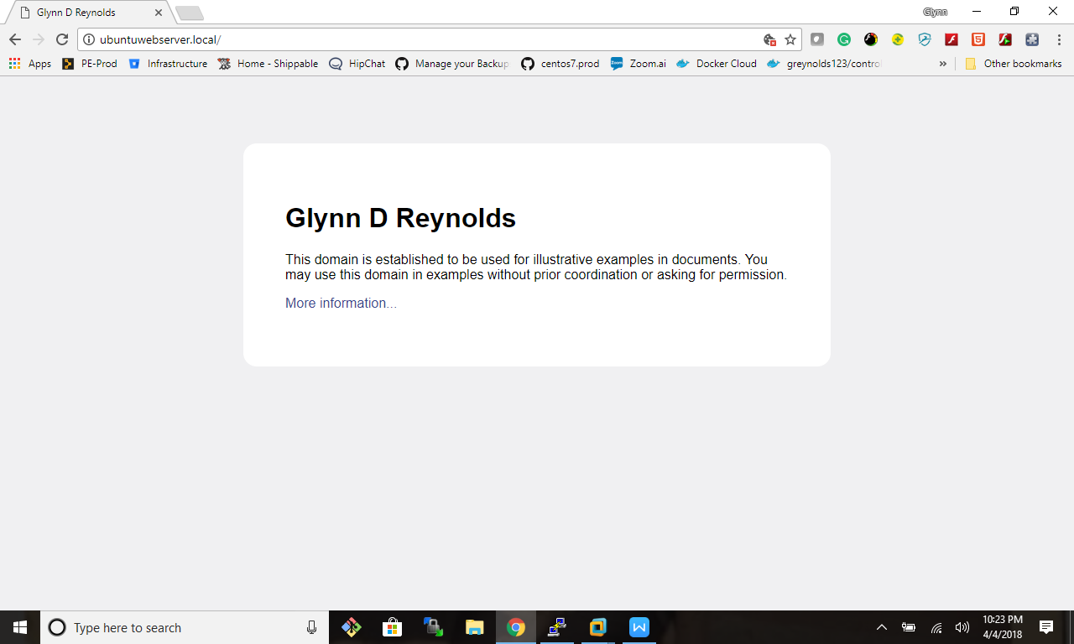

Here are the forwarders

root@ubuntuDNSserver:/etc/bind# view named.conf.options

options {

directory "/var/cache/bind";

// If there is a firewall between you and nameservers you want

// to talk to, you may need to fix the firewall to allow multiple

// ports to talk. See http://www.kb.cert.org/vuls/id/800113

// If your ISP provided one or more IP addresses for stable

// nameservers, you probably want to use them as forwarders.

// Uncomment the following block, and insert the addresses replacing

// the all-0's placeholder.

forwarders {

10.106.3.2;

216.58.217.206;

1.1.1.1;

8.8.8.8;

4.4.4.4;

};

//========================================================================

// If BIND logs error messages about the root key being expired,

// you will need to update your keys. See https://www.isc.org/bind-keys

//========================================================================

dnssec-validation auto;

auth-nxdomain no; # conform to RFC1035

listen-on-v6 { any; };

};

Configurations for the firewall

root@ubuntuDNSserver:/etc/bind# ufw status

Status: active

To Action From

-- ------ ----

53 DENY Anywhere

22 ALLOW Anywhere

Bind9 ALLOW Anywhere

953 DENY Anywhere

953/udp ALLOW Anywhere

953/tcp ALLOW Anywhere

389/tcp ALLOW Anywhere

389/udp ALLOW Anywhere

53/tcp ALLOW Anywhere

53/udp ALLOW Anywhere

53 (v6) DENY Anywhere (v6)

22 (v6) ALLOW Anywhere (v6)

Bind9 (v6) ALLOW Anywhere (v6)

953 (v6) DENY Anywhere (v6)

953/udp (v6) ALLOW Anywhere (v6)

953/tcp (v6) ALLOW Anywhere (v6)

389/tcp (v6) ALLOW Anywhere (v6)

389/udp (v6) ALLOW Anywhere (v6)

53/tcp (v6) ALLOW Anywhere (v6)

53/udp (v6) ALLOW Anywhere (v6)

Custom Zone

;

; BIND data file for local loopback interface

;

$TTL 604800

@ IN SOA ubuntuDNSserver.local. root.ubuntuDNSserver.local. (

10 ; Serial

604800 ; Refresh

86400 ; Retry

2419200 ; Expire

604800 ) ; Negative Cache TTL

;

@ IN NS ubuntuDNSserver.local.

@ IN A 10.106.3.126

@ IN AAAA ::1

;

; Parent Name Server

ns IN A 10.106.3.126

;

; Web Server

web IN CNAME www

www IN A 10.106.3.127

ubuntuWebServer IN A 10.106.3.127

127.3.106 IN PTR ubuntuWebServer.

;

; End of File